BANKNOTES RECONITION SYSTEM

Natchanon Sayasonti 5988116

Wannaporn Vichaisri 5988266

**Graphic User Interface**

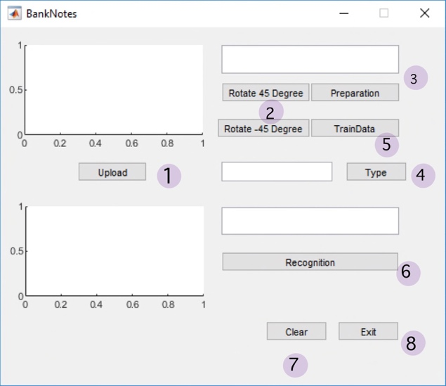

Figure 1: User Interface

**Implementation**

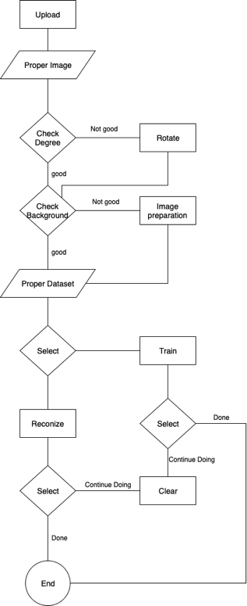

Figure 2: Flow chart of Implementation Process

1.Upload

global image;

global pic;

global filename;

[filename pathname]=uigetfile({'*.bmp','*.jpg'},'file select');

image = strcat(pathname,filename);

pic = imread(image);

axes(handles.axes1); imshow(pic);

axes(handles.axes2); cla;

set(handles.edit1,'string',filename);

2. Rorate 45 or -45 degree

global pic

pic = imrotate(pic,45);

% imrotate(pic,-45)%

axes(handles.axes1); imshow(pic);

3. Preparation [Crop an object]

global pic;

hsvImage = rgb2hsv(pic);

sImage = hsvImage(:, :, 2);

mask = sImage > 0.1;

mask = bwareafilt(mask,1);

mask = imfill(mask, 'holes');

props = regionprops(logical(mask),

'BoundingBox');

croppedImage = imcrop(pic, props.BoundingBox);

axes(handles.axes1);

imshow(croppedImage);

4. Color Recognition

global pic;

 r=mean(mean(pic(:,:,1)));

 g=mean(mean(pic(:,:,2)));

 b=mean(mean(pic(:,:,3)));

 Thou = abs(r-b);

 %Thou > 3 is not 1000%

 onethou = false;

 if Thou <=3

     onethou = true;

 end

 if (r > g) && (r > b)  && (onethou == false)

     set(handles.edit3,'string','100');

         elseif (b>r) && (b>g)&& (onethou == false)

     set(handles.edit3,'string','50');

 elseif (g>b) && (g>r)  && (onethou == false)

      set(handles.edit3,'string','20');

         else

     set(handles.edit3,'string','1000 or 500');

 end

5. Preparing data for Euclidean distance Recognition [Train]

global pic;

global filename;

global excel;

excel = 'E:\MATLAB\R2018\bin\Project\DB_Train.xlsx';

tab=xlsread(excel);

[rr,cc]=size(tab);

% ............................ Calculate Features

 mred=mean(mean(pic(:,:,1)));

 mgreen=mean(mean(pic(:,:,2)));

 mblue=mean(mean(pic(:,:,3)));

 gray=rgb2gray(pic);

 mgray=mean(mean(gray));

 %energy

 gray=rgb2gray(pic);

 glcm = graycomatrix(gray, 'o', [0,1]);

 S = graycoprops(glcm);

 energy = S.Energy*100;

 %entropy

 rngfil = rangefilt(pic);

 entro = entropy(rngfil)*100;

 %homo

 Homo = S.Homogeneity*100;

 %contrast

 Contrast = S.Contrast*100;

 %Correlation

 correlation=S.Correlation*100;

% ............................... calculate Excel Cell

 cell1=cat(2,'A',num2str(rr+2));

 cell2=cat(2,'B',num2str(rr+2));

 cell3=cat(2,'C',num2str(rr+2));

 cell4=cat(2,'D',num2str(rr+2));

 cell5=cat(2,'E',num2str(rr+2));

 cell6=cat(2,'F',num2str(rr+2));

 cell7=cat(2,'G',num2str(rr+2));

 cell8=cat(2,'H',num2str(rr+2));

 cell9=cat(2,'I',num2str(rr+2));

 cell10=cat(2,'J',num2str(rr+2));

% .................................. Write Excel Data

 xlswrite(excel,[{filename}],1,cell1);

 xlswrite(excel,[mred],1,cell2);

 xlswrite(excel,[mgreen],1,cell3);

 xlswrite(excel,[mblue],1,cell4);

 xlswrite(excel,[mgray],1,cell5);

 xlswrite(excel,[entro],1,cell6);

 xlswrite(excel,[energy],1,cell7);

 xlswrite(excel,[Homo],1,cell8);

 xlswrite(excel,[Contrast],1,cell9);

 xlswrite(excel,[correlation],1,cell10);

 system('taskkill /F /IM EXCEL.EXE');

6. Euclidean distance Recognition

global pic;

global excel;

excel = 'E:\MATLAB\R2018\bin\Project\DB_Train.xlsx';

datasetpath ='E:\MATLAB\R2018\bin\Project\Dataset\';

tab=xlsread(excel);

[rr,cc]=size(tab);

% ............................ Calculate Features

 data(1)=mean(mean(pic(:,:,1)));

 data(2)=mean(mean(pic(:,:,2)));

 data(3)=mean(mean(pic(:,:,3)));

 gray=rgb2gray(pic);

 data(4)=mean(mean(gray));

 gray=rgb2gray(pic);

 glcm = graycomatrix(gray, 'o', [0,1]);

 S = graycoprops(glcm);

 rngfil = rangefilt(pic);

 data(5) = entropy(rngfil)*100;

 data(6) = S.Energy*100;

 data(7) = S.Homogeneity*100;

 data(8) = S.Contrast*100;

 data(9) =S.Correlation*100;

% ............................ Matching

min=999;

rec=0;

for i=1 : rr

diff=0;

    for j=1 : cc

        diff=diff+sqrt(power(tab(i,j)-data(j),2));

    end

if (diff <=100)

    min=diff;

    rec=i;

end

end

if (rec ~= 0)

    %found

   cellx=cat(2,'A',num2str(rec+1));

    %cellx = A3

   [~,ff]=xlsread(excel,1,cellx);

   file=ff{1};

   imgfile = strcat(datasetpath,file);

   result=imread(imgfile);

   axes(handles.axes2); imshow(result);

file= strcat('Found : ',file);

   set (handles.edit2, 'string',file);

else

    % not found

   fig=zeros(250,300);

   axes(handles.axes2); imshow(fig);

   set (handles.edit2, 'string','NOT FOUND');

end

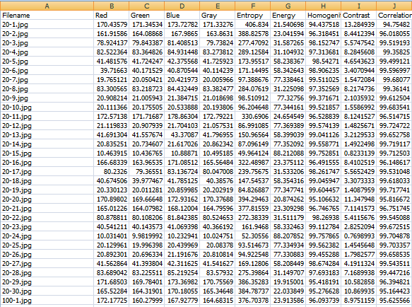

Figure 3: Data table from excel file

7. Clear a Data

axes(handles.axes1); cla;

axes(handles.axes2); cla;

set (handles.edit1, 'string','                         ');

set (handles.edit2, 'string','                         ');

8. Exit the System

close

**Experiment Result**

Thai Banknote Recognition System can recognize banknotes by 2 techniques which are Color Recognition and Euclidean distance Recognition. The experiment uses 12 pictures for each type of bank from the internet. For color recognition technique, it can recognize all pictures including both match and not match. Another technique which is Euclidean distance recognition can find only 1 match from all 60 banknotes.

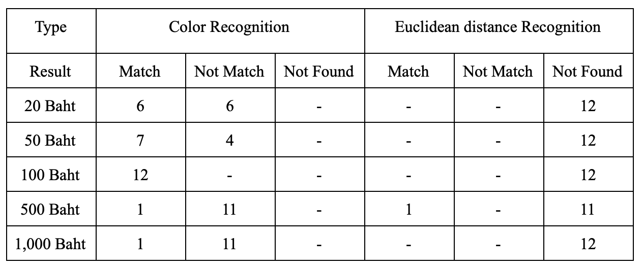

Figure 4: Result table from the experiment

**References**

[1] N.Panah and H.Masoumi, “Banknotes detected using Image Processing Techniques (2017)”, URL: https://www.ijcsmc.com/docs/papers/May2017/V6I5201710.pdf

[2] Rubeena Mirza and Vinti Nanda, “Paper Currency Verification System Based on Characteristic Extraction Using Image Processing (2012)”, URL: https://www.semanticscholar.org/paper

/Currency-Verification-System-Based-on-Extraction-Mirza-Nanda/0e8f89e2dae48ed45a6ba07b5b9523bebd64c015

[3] Vedasamhitha Abburu, Saumya Gupta, S. R. Rimitha, Manjunath Mulimani, and Shashidhar G. Koolagudi, “Currency recognition system using image processing (2017)”, URL: https://www.researchgate.net/publication

/323056402_Currency_recognition_system_using_image_processing

[4] Young-Ho Park, Seung Yong Kwon, Tuyen Danh Pham, Kang Ryoung Park, Dae Sik Jeong, and Sungsoo Yoon, ”A High-Performance Banknote Recognition System Based on a One-Dimensional Visible Light Line Sensor (2015)”, URL: https://www.researchgate.net/publication/278792894_A_High_Performance_Banknote_Recognition_System_Based_on_a_One-Dimensional_Visible_Light_Line_Sensor

[5] Akanksha Upadhyaya, Vinod Shokeen, and Garima Srivastava, “Decision tree model for classification of fake and genuine banknotes using SPSS (2018)”, URL: https://www.researchgate.net/publication

/330736939_Decision_tree_model_for_classification_of_fake_and_genuine_banknotes_using_SPSS

[6] Yueqiu Ren, “Banknotes Recognition in Real Time Using ANN”, URL: https://pdfs.semanticscholar.org/14a9/d6b7b99ea411c1fe85ab2869cb27209d9635.pdf

[7] MOHAMMAD ARIF, “IMAGE PROCESSING BASED FEATURE EXTRACTION OF CURRENCY NOTES”, URL: https://www.irjet.net/archives/V3/i4/IRJET-V3I4517.pdf

[8] Malladi Tejasvi, A.Nayeemulla Khan, A.Shahina, “Perfecting Counterfeit Banknote Detection - A Classification Strategy”, URL: https://www.ijitee.org/wp-content/uploads/papers/v8i6/F3597048619.pdf

[9] M.A. Zamalloa Jaraa, C. Luízar Obregónb, C. Araujo Del Castilloa, “Exploratory analysis for the identification of false banknotes using portable X-ray Fluorescence spectrometer”, URL: https://www.sciencedirect.com/science/article/pii/S0969804317300167

[10] Sumeet Shahani, Aysha Jagiasi, Priya R. L., “Analysis of Banknote Authentication System using Machine Learning Techniques”, URL: https://www.ijcaonline.org/archives/volume179/number20/shahani-2018-ijca-916343.pdf

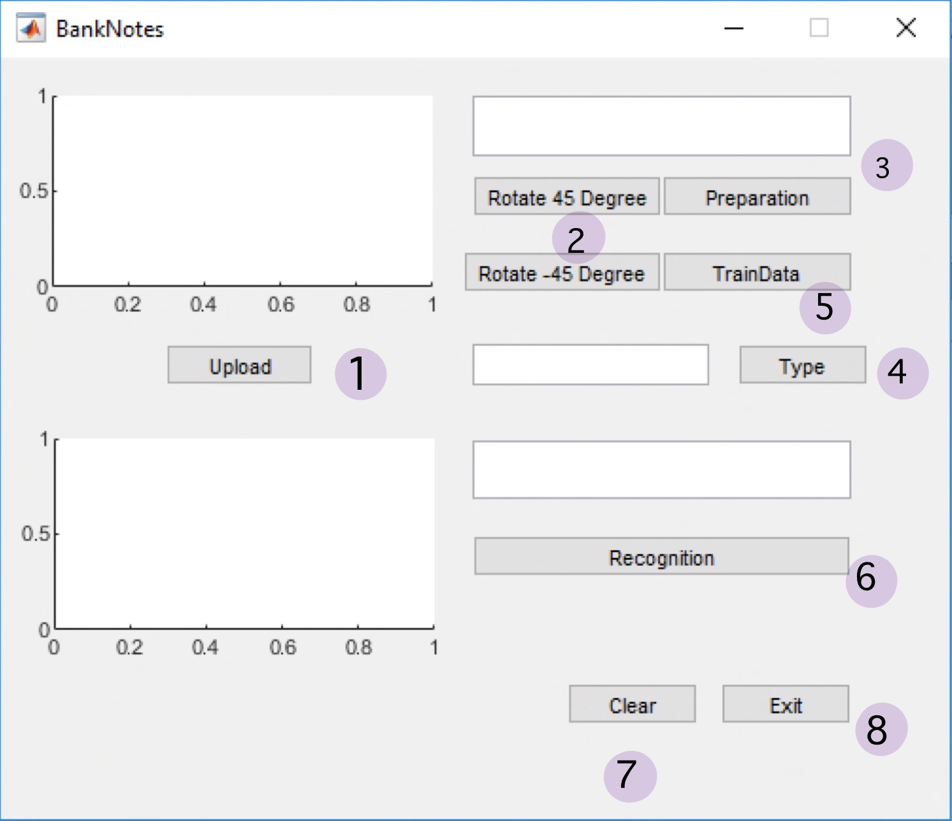

Figure 1: User Interface



Figure 2: Flow chart of Implementation Process



Figure 3: Data table from excel file



Figure 4: Result table from the experiment